Mapping charge carrier mobility at nanoscale
A. Alekseev^{1,2}, A. Yedrissov^{2,3}, S. Kharintsev⁴
¹National Research University “MIET”, 124498, Moscow, Russia
alalrus@gmail.com
²National Laboratory Astana, Nazarbayev University, 010000, Kazakhstan
³Karaganda State University, 100028, Karaganda, Kazakhstan
⁴Kazan Federal University, 420008, Kazan, Russia

Charge carrier mobility is important characteristic of semiconductors, which determine performance of the nanoelectronic devices. There are several methods for determination of average macroscopic mobility. One of the most widespread methods is based on space charge limited current (SCLC) measurements, which are performed on thin semiconductor films with flat electrodes. In case of monopolar injection, the Mott-Gurney equation is used for average mobility calculations over macroscopic area (typically few mm²) [1]. The attempts to use conductive atomic force microscopy (AFM) probe as localized top electrode and, thus, provide nanoscale CSLC measurements, lead to significantly higher mobility values. This fact is explained by complicated geometry of the electrodes when AFM probe is used on thin semiconductor films. O. Reid et al. [2] have derived semi-empirical equation for SCLC measurements in organic semiconductors by conductive-AFM (C-AFM). Here, we report on SCLC measurements of semiconducting polymer PTB7 by using C-AFM and following quantification of nanoscale hole mobility. It was shown that nanoscale current distribution is nonuniform and these nanoscale changes of current may be connected to existence of the crystallites in polymer, discovered by XRD methods earlier. It was also shown that SCLC takes place in all our samples and then measured C-AFM current density is proportional to the polymer hole mobility. The current density on film thickness dependence was determined and modification of Reid-Ginger equation [2] based on obtained data was offered. For local mobility mapping the I-V curves were measured at each point of scan. It is concluded that careful estimation of built-in voltage V_{bi} is required at each point, since the value of V_{bi} is not constant on surface. The value of V_{bi} estimated from C-AFM measurements was significantly higher than buil-in voltage in macroscopic SCLC measurements (up to 2 V). Finally, the map of hole mobility in PTB7 was calculated from modified Reid-Ginger model [2] adapted to our results by using measured I-V curves and estimated map of V_{bi} (Figure 1). It is seen that the hole mobility map has features of both current map I(x,y) and V_{bi}(x,y), i.e. in general the current image does not directly correlate with the mobility map due to variations of V_{bi} on surface.
a)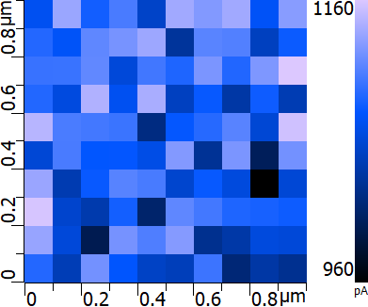 b) 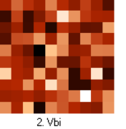c) 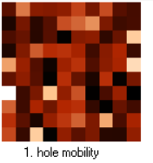
Figure 1. a) cross-section of I-V curves on PTB7 film at 3 V, b) distribution of V_{bi}, c) hole mobility map. Brighter colors correspond to higher values.
This work was supported by Federal Target Program of MES of Russian Federation, contract 14.575.21.0149 (RFMEFI57517X0149).
- M.A. Lampert, P. Mark, Current Injection in Solids (Academic Press), 363 (1970)
- O.G. Reid, K. Munechika, D.S. Ginger, Nano Lett. 8, 1602 (2008).

